4.7 ANSWERS TO EXERCISES

4.7 Exercise 1

1. a) C₂H₅Cl + 2NH₃ → C₂H₅NH₂ + NH₄Cl


b) C₂H₅NH₂ + C₂H₅Cl → (C₂H₅)₂NH + HCl
(C₂H₅)₂NH + C₂H₅Cl → (C₂H₅)₃N + HCl
(C₂H₅)₃N + C₂H₅Cl → (C₂H₅)₄N⁺Cl⁻

c) starting compound – CH₃CN
reagent – LiAlH₄ in dry ether
CH₃CN + 4[H] → CH₃CH₂NH₂

d) The reduction from a nitrile will give a higher yield
as the primary amine is the only product formed

2. a) CH₃Br + 2NH₃ → CH₃NH₂ + NH₄Cl
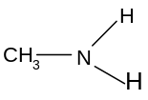
b) C₂H₅Cl + NH₃ → C₂H₅NH₂ + HCl
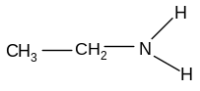
c) CH₃Br + C₂H₅NH₂ → C₂H₅NH(CH₃) + HCl
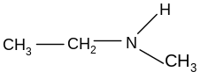
d) CH₃CHClCH₃ + C₂H₅NH(CH₃) → CH₃CH(CH₃)N(C₂H₅)(CH₃) + HCl
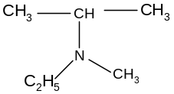
e) C₂H₅Br + (C₂H₅)₃N → (C₂H₅)₄N⁺Br⁻
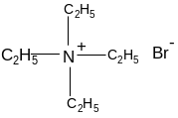
f) 3CH₃Cl + NH₃ → (CH₃)₃N + 3HCl
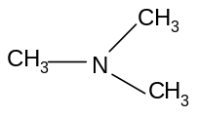

g) CH₃CH₂CN + 4[H] → CH₃CH₂CH₂NH₂
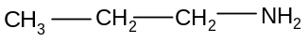
3. a)
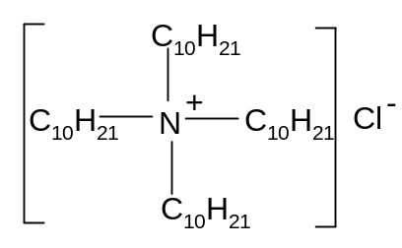
b) quartenary ammonium salt
c) cationic surfactant

4. a) i) NH₃(aq) + H₂O(l) == NH₄⁺(aq) + OH⁻(aq)
ii) C₂H₅NH₂(aq) + H₂O(l) == C₂H₅NH₃⁺(aq) + OH⁻(aq)
b) The solution in part (ii) will have a higher pH
The ethyl group pushes electrons on to the N atom
This makes the lone pair more available for donation
c) i) C₂H₅NH₂ + HCl → C₂H₅NH₃⁺Cl⁻
ii) 2(CH₃)₂NH + H₂SO₄ → [(CH₃)₂NH]⁺₂SO₄²⁻
iii) (CH₃)₂NC₂H₅ + HCl → [(CH₃)₂NHC₂H₅]⁺Cl⁻

